
39 Partridge Street, Glenelg

Contact Details:
Head of Sport and PE
Tom Mitton: 0435 138 037 or tmitton@spw.sa.edu.au

 | McKenzie Playing Field |  | Braested Playing Field
8:20 | Under 9’s – White Competition | 8:15 | Senior Primary – Red Competition
9:10 | Under 10’s – Blue Competition | 9:15 | Senior Primary – Green Competition
10:00 | Under 10’s – Red Competition | 10:15 | Senior Primary – Purple Competition

A coffee cart and BBQ are available for all home games. The coffee cart will be next to the McKenzie Fields.

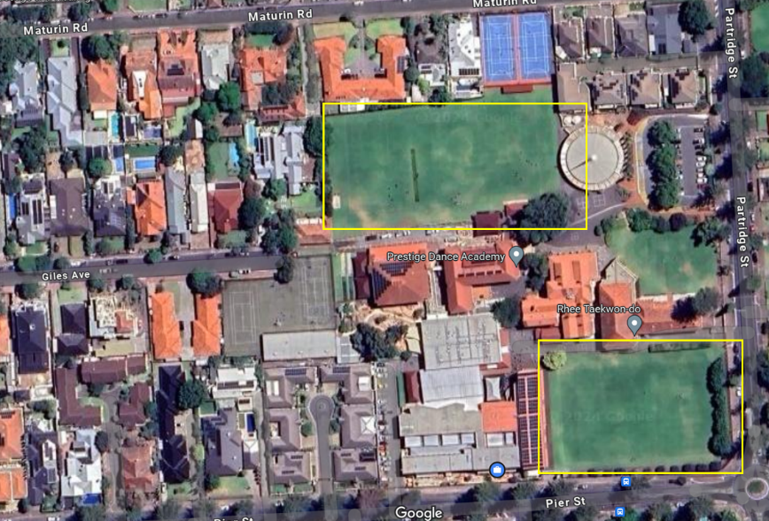

Warmup/practice fields

McKenzie Playing Field (near school Chapel, enter off Partridge Street)
Braested Playing Field (parallel to Pier Street, enter via pedestrian gate)
Green fields can be used to warm up on

