St Leonards Primary School
Glenelg North

******Please note oval entrance is off Russell Street******

Soccer Co-ordinators Scott Heywood 0402 049 203
slpssoccer@gmail.com
Sarah van Eyk 0428 828 862
slpssoccer@gmail.com

2025 Game Times:
Under 7 (Red) 8:00am Pitch 2
Under 8 St Leonards 2 (Blue) 8:00am Pitch 1
Under 8 St Leonards 1 (Red) 8:50am Pitch 2
Under 9 St Leonards 2 (White) 8:50am Pitch 1
Under 9 St Leonards 1 (Red) 8:00am Pitch 3
Under 10 (Red) 8:50am Pitch 3
St Leonards Seniors 3 (Blue) 9:50am
St Leonards Seniors 2 (White) 10:50am
St Leonards Seniors 1 (Red) 11:50am

We have a coffee van, BBQ with sausages, eggs, bacon. Cash and eftpos available.

See map on next page.

Games at 8:00 am |  |  | Games at 8:50 am
U7 Red – Pitch 2 |  |  | U8 Red (St Leonards 1) – Pitch 2
U8 Blue (St Leonards 2) – Pitch 1 |  |  | U9 White (St Leonards 2) – Pitch 1
U9 Red (St Leonards 1) – Pitch 3 |  |  | U10 Red – Pitch 3
Seniors games at 9:50 (Blue) , 10:50 (White), 11:50 (Red) on full pitch
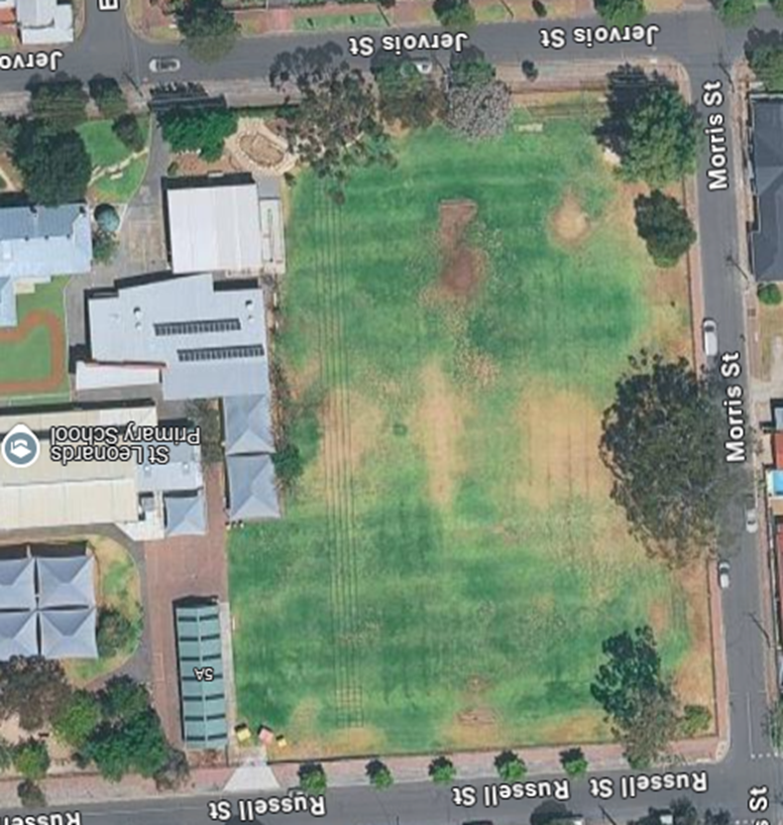
Pitch 1

---------------No standing--------------
Pitch 3

Pitch 2

