
St John’s Grammar
2026 Junior School
Soccer Information

Address: St John’s Senior Campus, 29 Gloucester Avenue, Belair
DATE | VENUE - St Johns Grammar Secondary Campus – Gloucester Ave, Belair
 | Under 7 #1 | Under 7 #2 | Under 9 – Green |  | Under 10 White | Senior Purple | Senior White
16/5 | AWAY vs  Craigburn | HOME vs  Warradale  11:00 kick-off | AWAY vs  Clapham |  | Away vs  Annesley | AWAY vs  Scotch | AWAY vs McAuley
23/5 | AWAY vs  Forbes | AWAY vs  Forbes | BYE |  | HOME vs Westbourne Park 8:30 kick-off | HOME vs  St Joseph’s Kingswood  9:30 kick-off | HOME vs  Westbourne Park  10:30 kick-off
30/5 | AWAY vs  Seaview Downs | AWAY vs  Brighton | HOME vs  Woodend  8:00 kick-off |  | HOME vs  Stelle Maris  9:00 kick-off | HOME vs  Woodend  10:00 kick-off | HOME vs  Stella Maris  11:00 kick-off
6/6 | NO GAMES LONG WEEKEND
13/6 | BYE | AWAY vs  Seacliff | AWAY vs  Emmaus | AWAY vs  Black Forest |  | HOME vs  Our Lady of Grace  11:00 kick-off | AWAY vs  Black Forest
20/6 | HOME vs  Clapham  11:00 kick-off | AWAY vs  Happy Valley | AWAY vs  Reynella East | AWAY vs  Belair |  | AWAY vs  Blackwood | AWAY vs  Belair
27/6 | ST JOHN’S UNAVAILABLE  GAMES MOVED TO SATURDAY 29/8
 | SCHOOL HOLIDAYS
25/7 | HOME vs  St Thomas  8:00 kick-off | AWAY vs  Coromandel Valley | AWAY vs  Goodwood | AWAY vs  Forbes |  | AWAY vs  Goodwood | AWAY vs  Goodwood
1/8 | AWAY vs  Goodwood | AWAY vs  Goodwood | AWAY vs  Colonel Light Gardens | AWAY vs  Colonel Light Gardens |  | AWAY vs  Colonel Light Gardens | AWAY vs  Colonel Light Gardens
8/8 | AWAY vs  Annesley | AWAY vs  Edwardstown | AWAY vs  St Martin De Porres | AWAY vs  Blackwood |  | AWAY vs  Blackwood | AWAY vs  St Leonard’s
15/8 | HOME vs  Happy Valley  11:00 kick-off | AWAY vs  Seaview Downs | HOME vs  Woodcroft  11:00 kick-off | AWAY vs  St Thomas |  | AWAY vs  Upper Sturt  (St John’s unable to host) | HOME vs  St John’s the Baptist  12:00 kick-off
22/8 | AWAY vs  Sunrise Fullarton | HOME vs  St John’s the Baptist  8:00 kick-off | AWAY vs  Coromandel Valley | AWAY vs  Unley |  | AWAY vs  Aberfoyle Campus | AWAY vs  Aberfoyle Hub
29/8 | AWAY vs  Flagstaff Hill | HOME vs  Emmaus  8:00 kick-off | HOME vs  Mitcham  8:00 kick-off | HOME vs  Seacliff  9:00 kick-off |  | HOME vs  Sunrise Fullarton  10:00 kick-off | HOME vs  Mitcham Primary  11:00 kick-off

Map next page

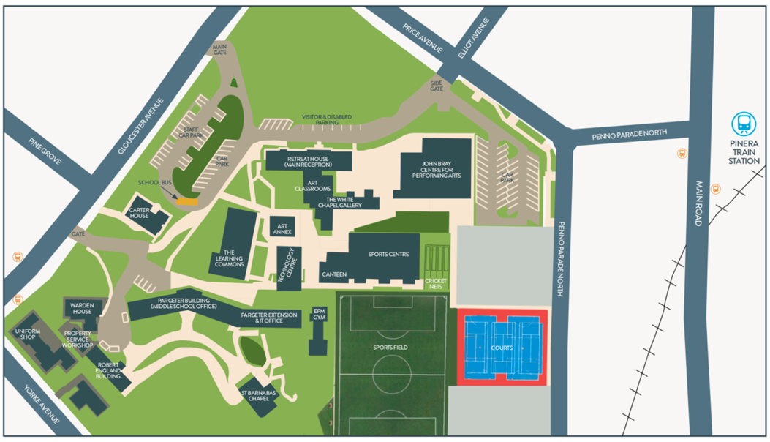

Contact Information
Charlie Zammit (Head of Sport)
M: 0438 334 150
E: CZammit@stjohns.sa.edu.au

Michael Adams (Sport & Extra Curricular Assistant) (AWAY TERM 3 WEEK 1-3)
M: 0419 713 378
E: MAdams@stjohns.sa.edu.au

