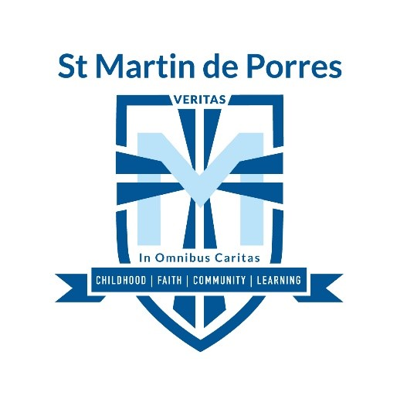

HOME GROUND ADDRESS: 1 Berrima Road, Sheidow Park 5158

HOME GAME TIMES
Under 8: 8.30am
Senior Primary: 9.30am

Soccer Coordinator: Gabby Bates 8321 8300 during school hours
gbates@smdps.catholic.edu.au

Under 8 Coach: Phillip Lloyd 0418 586 524
Under 8 Manager: Lisa Sharma 0417 842 896

Senior Primary Coach: Jason Jennings 0415 536 951

