MERCEDES COLLEGE
PRIMARY SOCCER HOME FIXTURES

U8 & U9 & U10
Home: Mercedes College, enter school via Delamere Avenue, Springfield (see blue star on map).
U8 (Red Division) = 8:30am Start
U9 (White Division) = 9:00am Start
U10 (White Division) = 9:30am Start (please note that we have had to move to U8/U9 field/dimensions)
*Changed times on 22/5 due to change of U10 schedule on 22/5
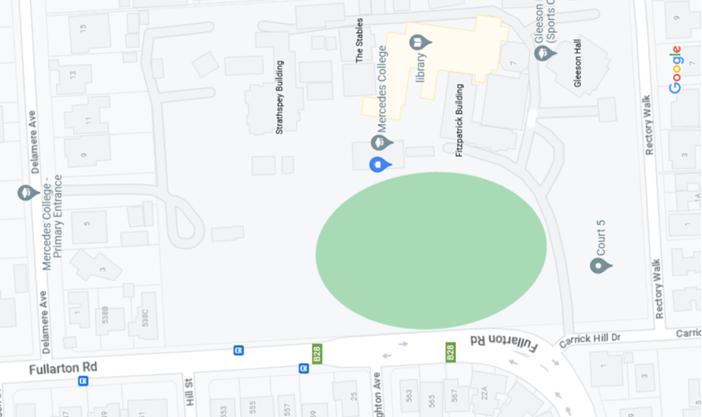

SENIOR GOLD, SENIOR GREEN
Home: St Pauls Retreat / The Monastery; 15 Cross Roads, Urbbrae (near the Freeway intersection)
Senior Green (2 in Orange Division) = 8:30am Start
Senior Gold (1 in White Division) = 9:30am Start
*Changed times on 22/5 due to change of U10 schedule on 22/5
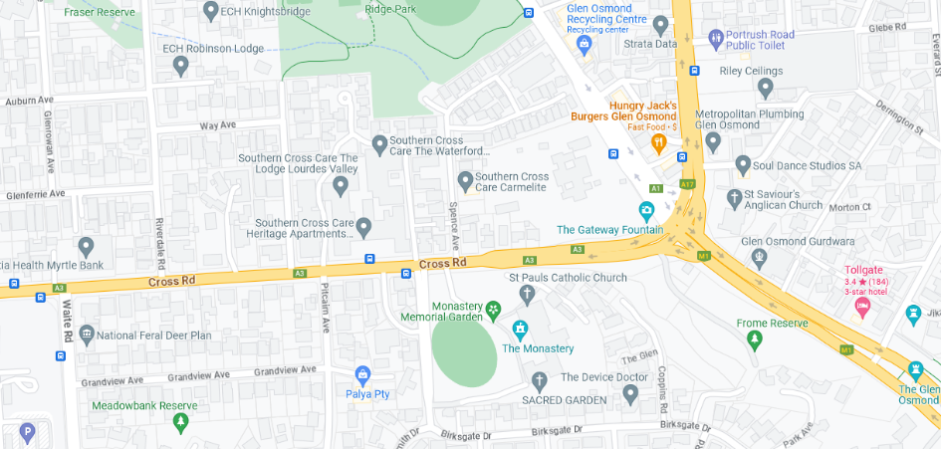

COORDINATOR
Jeffrey Wray
jwray@mercedes.catholic.edu.au
0429 018 679

